**PNAS Template for Supplementary Information**

This PNAS template for supplementary information (SI) may be used to organize your SI Appendix. **Once formatted, this first page should be deleted.** The template is intended to provide a clearly organized PDF that readers can easily navigate to specific information, figures, and tables. Movie files or large datasets must be presented as separate files. Further information is available in the [PNAS Author Center](https://www.pnas.org/authors/submitting-your-manuscript#Supporting_Information).

**Using the Template**

Paste the appropriate text (title, author list, and corresponding authors) into the cover page. You may maintain the template formatting or reapply the styles after pasting your text into the template. On the cover page, complete the relevant description of the SI and delete text that does not apply.

Supporting information for Brief Reports is limited to extended methods, essential supporting datasets, and videos (no additional tables or figures).

SI figures should be placed on separate pages with a figure legend set immediately below each figure. Table titles should be set immediately above each SI table. Note that tables extending beyond the width of the page can be included; nonstandard page sizes are accepted as part of your SI Appendix file.

All references cited in the SI Appendix should be included in a separate reference list at the end of this file.

**Submitting SI**

Delete this first page and save your completed SI Appendix file as a PDF. Submission instructions are available [here](https://www.pnas.org/authors/submitting-your-manuscript).

*Updated September 2020*



**Supplementary Information for**

Which national factors are most influential in the spread of COVID-19?

Hakyong Kim, Catherine Apio, Yeonghyeon Ko, Kyulhee Han, Taewan Goo, Gyujin Heo, Taehyun Kim, Hyewon Chung, Doeun Lee, Jisun Lim

Taesung Park

Email: tspark@snu.ac.kr

**This PDF file includes:**

Supplementary text

Figures S1 to S12

Tables S1 to S4

|  |  |  |  |
| --- | --- | --- | --- |
| **Summary of national factors** | | | |
| **Source** | **Category** | **Variable name** | **Variable information** |
| ***Our World in Data*** | ***Territory, Population*** | Population (2020) | Population in 2020 |
| Population Density (2020) | The number of people in a given area divided by the area of ​​the given area. Usually expressed as population per |
| ***National Accounts*** | GDP per capita | Gross domestic product divided by the number of people |
| ***Age*** | Median Age (2020) | Median age of the population, UN projection for 2020 |
| Aged 65 older | Share of the population that is 65 years and older, most recent year available |
| Age 70 older (2015) | Share of the population that is 70 years and older in 2015 |
| Life Expectancy (2019) | The average number of years a 0-year-old is expected to survive in the future |
| ***Health, Society, And Welfare*** | Cardiovascular Death Rate (2017) | Death rate from cardiovascular disease in 2017 (annual number of deaths per 100,000 people) |
| Diabetes Prevalence (2017) | Diabetes prevalence (% of population aged 20 to 79) in 2017 |
| Female Smokers | Share of women who smoke, most recent year available |
| Male Smokers | Share of men who smoke, most recent year available |
| Handwashing Facilities | Share of the population with basic handwashing facilities on premises, most recent year available |
| Hospital Beds per thousand | Hospital beds per 1,000 people, most recent year available since 2010 |
| Extreme Poverty | Share of the population living in extreme poverty, most recent year available since 2010 |
| ***Education, Culture, Science*** | Human Development Index | Summary measure of average achievement in key dimensions of human development: a long and healthy life, being knowledgeable and have a decent standard of living |
| ***KOSIS*** | ***Trade*** | Exports to GDP Ratio (2016) |  |
| Imports to GDP Ratio (2016) |  |
| ***Environment*** | Average Annual Temperature (1961-1990) | 30-year statistics from 1961 to 1990 based on observed temperature |
| Annual Precipitation (1961-1990) | 30-year statistics from 1961 to 1990 based on observed precipitation |
| ***National Accounts*** | Gross Domestic Product (2018) | A monetary measure of the market value of all the final goods and services produced in a specific time period |
| ***Territory, Population*** | Proportion of Urban Population (2018) | The proportion of the population living in urban areas among the total population (However, the concept of cities in each country is different, and the urban population of each country is based on the census of each country.) |
| Total Fertility Rate (2020) | Average of the number of children a woman has in her lifetime |
| Net Migration Rate (2020) | The number of the number of transferees minus the number of transferees over a specific period divided by the total population of the period |
| ***Education, Culture, Science*** | Number of international travelers (2017) | The number of foreign tourists with each country's nationality expressed in units of thousands |
| Number of foreign visitors (2017) | The number of foreign visitors to each country expressed in units of thousands |
| National Competitiveness (2019) | The ranking of national competitiveness announced by the Swiss Institute of International Business Development (IMD) (Consider areas such as economic performance, government efficiency, corporate efficiency, and infrastructure) |
| ***Health, Society, And Welfare*** | Infant vaccination rate (2017) | The infant immunization rate is the percentage of infants 12 to 23 months of age who were vaccinated 12 months before or before the investigation of four diseases, measles and DPT (diphtheria, whooping cough, tetanus) |
| Public Social Welfare Expenditure (2016) | Social benefits or financial assistance by public institutions while households or individuals are in a disadvantaged environment (Expressed as a percentage of GDP) |
| Pharmaceutical Sales (2018) | Total sales based on the retail price of the drug's final sales, classified by ATC code (Anatomical Therapeutic Chemical Classification System) |
| Percentage of malnourished population (2016) | Percentage of the population who consistently consume food at a level lower than the minimum dietary energy consumption |
| ***Age*** | Aging index (2020) | (Population over the age of 65 in the current year ÷ Population between 0 and 14 in the current year) × 100 |

**Table S1**. List of the national factors used.

**Pseudo-code of Segmentation Algorithm**

Here, we denote by .

|  |
| --- |
| **Algorithm 1** Peak Detection Algorithm |
| 1. (Initialization)  declare where  2. (Local maximum condition)  **while** **do**  **if** **then**    **end if**  **end while**  3. (Excluding small peaks)  **if** **then**    **end if**  4. (Resolution criteria)  **if** **then**  declare *p* = 1,  **while** *p* **do**  **if** **then**  **if** **then**    **else**    **end if**  **else**    **end if**  *p* *p+1*  **end if**  5. (Exclude peaks which are vibrations on increasing trend)  **if** **then**  declare ;  **if** **then**    **end if**  **end if** |

|  |
| --- |
| **Algorithm 2** Breakpoint Detection Algorithm |
| 1. (Initialization)  declare  2. (Between peaks)  **if** **then**  **for each** **do**  B;  **end do**  **end if**  3.(After the last peak)  declare U  **if** **then**  B ;  **end if** |

|  |
| --- |
| **Algorithm 2** Breakpoint Detection Algorithm |
| 1. (Initialization)  declare  2. (Between peaks)  **if** **then**  **for each** **do**  B;  **end do**  **end if**  3.(After the last peak)  declare U  **if** **then**  B ;  **end if** |

**Fig. S1.** Pseudo-codes for the Segmentation Algorithm

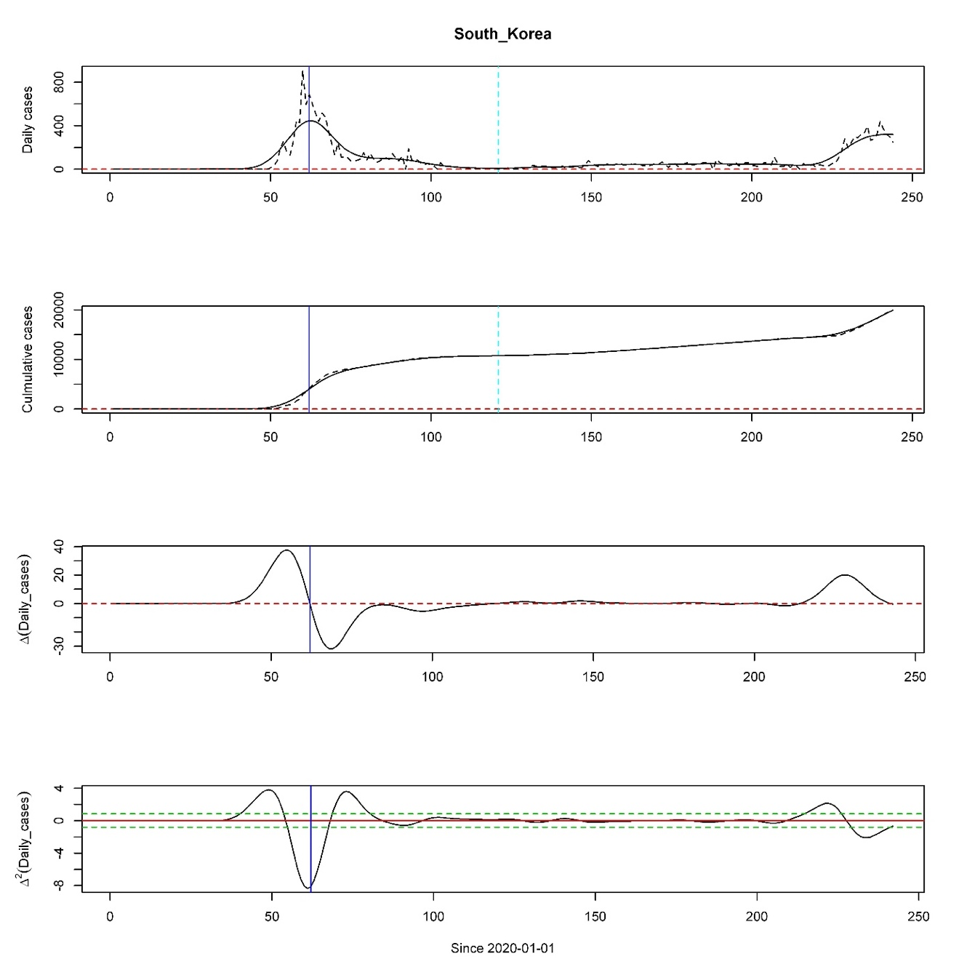

**Fig. S2. Segmentation algorithm applied to South Korea’s COVID-19 daily new confirmed cases.** Theblue line represents the peak and dotted sky-blue line represents breakpoint. In the 1st plot, black solid line represents and black dotted line represents . The 2nd plot represents cumulative confirmed cases of (black dotted line), (black solid line). 3rd, 4th plots are graphs of . In 4th plot, green dotted line represents sensitivity level. If is above the upper green dotted line, is concave. On the other hand, if is below the lower green dotted line, is convex.

|  |  |  |  |  |  |  |  |  |
| --- | --- | --- | --- | --- | --- | --- | --- | --- |
| **Segmented Logistic Model** | | | | | | | | |
|  |  | **1st Segment** | | | **2nd Segment** | | |  |
| **Country** | **Maximum Cumulative cases** |  |  |  |  |  |  | **MSSE** |
| Afghanistan | 38162 | 37269.8509 | 5.6770 | 0.0743 | NA | NA | NA | 0.0285 |
| Albania | 9380 | 29521.2462 | 5.3078 | 0.0268 | NA | NA | NA | 0.0292 |
| Algeria | 44146 | 12006.8756 | 3.7504 | 0.0622 | 34805.8852 | 3.8383 | 0.0758 | 0.0296 |
| Angola | 2624 | 3210.7931 | 5.3484 | 0.0605 | NA | NA | NA | 0.1101 |
| Argentina | 401226 | 648605.7127 | 7.0822 | 0.0434 | NA | NA | NA | 0.0253 |
| Armenia | 43750 | 43766.2039 | 5.5276 | 0.0542 | NA | NA | NA | 0.0164 |
| Aruba | 1997 | 2036.3519 | 23.7171 | 0.1651 | NA | NA | NA | 0.4136 |
| Australia | 25670 | 6874.2219 | 5.5232 | 0.1993 | 19130.8848 | 5.7873 | 0.1019 | 0.0723 |
| Austria | 27218 | 15908.5183 | 4.2740 | 0.1596 | 16850.1551 | 3.8620 | 0.0498 | 0.1512 |
| Azerbaijan | 36309 | 39349.2968 | 5.7054 | 0.0523 | 2314.9887 | 3.1543 | 0.3069 | 0.0355 |
| Bahamas | 2167 | 2725.7862 | 11.5786 | 0.0902 | NA | NA | NA | 0.1529 |
| Bahrain | 51574 | 52482.2417 | 5.2532 | 0.0432 | NA | NA | NA | 0.0522 |
| Bangladesh | 310822 | 309918.2068 | 4.8411 | 0.0488 | NA | NA | NA | 0.0632 |
| Belarus | 71687 | 67674.9628 | 4.3724 | 0.0640 | 3143.6539 | 3.1136 | 0.2155 | 0.0513 |
| Belgium | 85442 | 59026.3230 | 4.1785 | 0.1002 | 25594.5256 | 4.4737 | 0.0989 | 0.0589 |
| Bolivia | 115968 | 136119.5696 | 5.7989 | 0.0465 | NA | NA | NA | 0.0150 |
| Bosnia and Herzegovina | 19789 | NA | NA | NA | NA | NA | NA | NA |
| Brazil | 3862311 | 4453662.2090 | 5.5266 | 0.0408 | NA | NA | NA | 0.0335 |
| Bulgaria | 16190 | 2847.4247 | 3.4207 | 0.0696 | 14226.6135 | 4.0922 | 0.0691 | 0.0347 |
| Cameroon | 19142 | 21027.7178 | 4.5991 | 0.0509 | 6228.8127 | 2.3642 | 0.1062 | 0.2697 |
| Canada | 127940 | 102198.2467 | 4.1626 | 0.0711 | 23205.5724 | 2.7602 | 0.0880 | 0.0676 |
| Cape Verde | 3852 | 451.6892 | 3.0462 | 0.1095 | 3709.0145 | 3.4858 | 0.0529 | 0.0886 |
| Central African Republic | 4700 | 4681.4703 | 4.6191 | 0.0867 | NA | NA | NA | 0.0584 |
| Chile | 409974 | 386213.7660 | 6.2397 | 0.0635 | NA | NA | NA | 0.1951 |
| China | 89868 | 84438.2778 | 5.2721 | 0.1958 | NA | NA | NA | 0.3252 |
| Colombia | 607938 | 1028559.6439 | 7.1185 | 0.0441 | NA | NA | NA | 0.0114 |
| Congo | 3979 | 4512.6300 | 5.1438 | 0.0508 | NA | NA | NA | 0.2155 |
| Costa Rica | 39699 | 53094.5266 | 8.5012 | 0.0555 | NA | NA | NA | 0.0682 |
| Cote’ d Ivoire | 17948 | 19182.4988 | 5.3947 | 0.0525 | 889.9903 | 3.0251 | 0.3372 | 0.0898 |
| Croatia | 10123 | 2171.0152 | 3.1237 | 0.1317 | 13184.8289 | 4.3545 | 0.0482 | 0.2648 |
| Cuba | 3973 | 1856.7584 | 3.4571 | 0.1238 | 424.2954 | 3.0161 | 0.1868 | 0.0354 |
| Czechia | 24367 | 8425.2168 | 3.4373 | 0.1147 | 20390.7458 | 3.6332 | 0.0476 | 0.1193 |
| Democratic Republic of the Congo | 10044 | 9704.1760 | 4.8552 | 0.0575 | 208.7552 | 3.3273 | 0.6117 | 0.0521 |
| Denmark | 16700 | 12229.4185 | 3.0248 | 0.0747 | 4665.2456 | 4.2840 | 0.1044 | 0.1107 |
| Djibouti | 5385 | 1051.5098 | 4.9399 | 0.3115 | 3980.2177 | 4.0720 | 0.1357 | 0.2622 |
| Dominican Republic | 94241 | 143968.8886 | 4.5142 | 0.0321 | NA | NA | NA | 0.0887 |
| Ecuador | 117639 | 41796.9588 | 5.4738 | 0.1175 | 84434.3146 | 3.0774 | 0.0511 | 0.2161 |
| Egypt | 98727 | 99949.4036 | 6.4644 | 0.0618 | NA | NA | NA | 0.0104 |
| El Salvador | 25729 | 34877.7380 | 5.4834 | 0.0438 | NA | NA | NA | 0.0450 |
| Equatorial Guinea | 4941 | 1692.8579 | 3.5291 | 0.0881 | 1949.5310 | 5.0940 | 0.2163 | 0.6387 |
| Estonia | 2373 | 1856.0023 | 2.6937 | 0.1019 | 534.2583 | 4.6425 | 0.0788 | 0.2039 |
| Eswatini | 4561 | 6353.9951 | 5.1505 | 0.0475 | NA | NA | NA | 0.0585 |
| Ethiopia | 51122 | NA | NA | NA | NA | NA | NA | NA |
| Finland | 8077 | 7134.7878 | 3.2117 | 0.0755 | 1033.3456 | 4.0422 | 0.0980 | 0.0628 |
| France | 278709 | 147092.5435 | 4.6031 | 0.1069 | NA | NA | NA | 0.1265 |
| Gabon | 8505 | 3546.9607 | 5.1536 | 0.1172 | 2908.7589 | 3.0856 | 0.1821 | 0.0465 |
| Gambia | 2963 | 3105.6876 | 6.4323 | 0.1387 | NA | NA | NA | 0.0751 |
| Georgia | 1487 | 175285.9159 | 4.7540 | 0.1159 | 152925.9558 | 3.6806 | 0.0373 | 0.0995 |
| Germany | 242381 | 9712.5829 | 5.4931 | 0.1023 | 41388.5308 | 3.5723 | 0.0616 | 0.1187 |
| Greece | 10134 | 2731.1379 | 3.3367 | 0.1120 | NA | NA | NA | 0.0929 |
| Guam | 1347 | NA | NA | NA | NA | NA | NA | NA |
| Guatemala | 73912 | 80489.4110 | 6.0005 | 0.0525 | NA | NA | NA | 0.0586 |
| Guinea | 9371 | 5303.4292 | 3.3438 | 0.0680 | 4510.1775 | 2.8192 | 0.0736 | 0.0819 |
| Haiti | 8209 | 7622.6502 | 4.7753 | 0.0824 | NA | NA | NA | 0.1544 |
| Honduras | 60174 | 56907.2114 | 6.3830 | 0.0564 | 11520.8129 | 3.0437 | 0.2570 | 0.0551 |
| Hungary | 5961 | 3964.0412 | 3.4650 | 0.0889 | 4036.5004 | 4.4656 | 0.0535 | 0.2645 |
| Iceland | 2105 | 1782.3982 | 4.3145 | 0.1763 | 478.7850 | 7.1262 | 0.0717 | 0.1771 |
| India | 3621245 | 6765888.4642 | 7.1224 | 0.0410 | NA | NA | NA | 0.0045 |
| Indonesia | 172053 | 245161.5902 | 4.7788 | 0.0316 | NA | NA | NA | 0.0201 |
| Iran | 373570 | 94307.3179 | 4.5510 | 0.1102 | 279269.4435 | 2.9052 | 0.0432 | 0.0531 |
| Iraq | 231177 | 286347.3795 | 7.2230 | 0.0466 | NA | NA | NA | 0.0971 |
| Ireland | 28760 | 25830.5125 | 4.2620 | 0.1063 | NA | NA | NA | 0.1508 |
| Honduras | 60174 | 16392.4036 | 4.3321 | 0.1391 | 81068.1196 | 6.1544 | 0.0895 | 0.0666 |
| Italy | 268366 | 234107.3748 | 4.0454 | 0.0874 | 152109.5321 | 4.8147 | 0.0551 | 0.1475 |
| Jamaica | 2357 | NA | NA | NA | NA | NA | NA | NA |
| Japan | 67865 | 16549.7588 | 7.8244 | 0.1231 | 58877.8030 | 6.7353 | 0.0859 | 0.0472 |
| Kazakhstan | 130673 | NA | NA | NA | NA | NA | NA | NA |
| Kenya | 34057 | 44506.1507 | 6.7577 | 0.0519 | NA | NA | NA | 0.0686 |
| Kosovo | 13334 | 19149.3567 | 5.9962 | 0.0424 | NA | NA | NA | 0.1251 |
| Kuwait | 84636 | 67873.6972 | 5.5275 | 0.0521 | 16566.5209 | 2.7567 | 0.1815 | 0.1562 |
| Kyrgyzstan | 43898 | 43306.2180 | 14.1798 | 0.1217 | NA | NA | NA | 1.0229 |
| Lebanon | 16870 | NA | NA | NA | NA | NA | NA | NA |
| Luxembourg | 8010 | 50974.5449 | 8.4007 | 0.0547 | NA | NA | NA | 0.0772 |
| Madagascar | 14843 | 3849.0711 | 3.0137 | 0.1560 | 3829.1249 | 5.4731 | 0.1022 | 0.1072 |
| Malawi | 5536 | 15669.2011 | 9.1087 | 0.0789 | NA | NA | NA | 0.0803 |
| Malaysia | 9334 | 427.7014 | 7.2719 | 0.2915 | 5118.5363 | 3.6000 | 0.0826 | 0.0599 |
| Maldives | 7667 | 6372.3634 | 3.9217 | 0.1149 | 2242.5502 | 2.1243 | 0.0925 | 0.2918 |
| Luxembourg | 8010 | 2220.3578 | 3.0390 | 0.0913 | 6468.6466 | 4.3292 | 0.0850 | 0.1165 |
| Mauritania | 7022 | 6640.6373 | 3.9054 | 0.0898 | NA | NA | NA | 0.1372 |
| Mexico | 641442 | 718779.9196 | 5.0133 | 0.0393 | NA | NA | NA | 0.0171 |
| Moldova | 36700 | 30054.5755 | 3.7987 | 0.0377 | 21681.3023 | 2.9687 | 0.0787 | 0.0713 |
| Montenegro | 4790 | 5040.4658 | 9.0828 | 0.0713 | 555.1335 | 3.0227 | 0.4366 | 0.3103 |
| Morocco | 61399 | NA | NA | NA | NA | NA | NA | NA |
| Mozambique | 3821 | 8769.4296 | 4.7192 | 0.0336 | NA | NA | NA | 0.0722 |
| Namibia | 7365 | 19752.6493 | 4.6521 | 0.0557 | NA | NA | NA | 0.0369 |
| Nepal | 38561 | 18780.2065 | 6.6411 | 0.1098 | 30689.6636 | 4.1320 | 0.1019 | 0.0727 |
| Netherlands | 70071 | 47727.8050 | 3.8502 | 0.0920 | 21992.4891 | 4.7197 | 0.1103 | 0.0793 |
| New Zealand | 1387 | 1117.4873 | 3.3022 | 0.2346 | NA | NA | NA | 0.0959 |
| Nicaragua | 4494 | 4483.4442 | 2.0435 | 0.0494 | NA | NA | NA | 0.2250 |
| Niger | 1176 | 56771.2201 | 4.7597 | 0.0449 | NA | NA | NA | 0.0283 |
| Nigeria | 53865 | 1555.4972 | 3.4741 | 0.1320 | 12680.0369 | 3.8436 | 0.0549 | 0.0639 |
| Norway | 10543 | 8479.5156 | 3.2578 | 0.1023 | 1761.7727 | 4.5090 | 0.1300 | 0.1522 |
| Oman | 85544 | 89246.7641 | 6.5958 | 0.0616 | NA | NA | NA | 0.0878 |
| Pakistan | 295849 | 294439.8470 | 6.1567 | 0.0648 | NA | NA | NA | 0.0493 |
| Palestine | 29063 | 30248.6952 | 9.1084 | 0.0669 | NA | NA | NA | 0.1613 |
| Panama | 92065 | 117314.2780 | 4.9029 | 0.0364 | NA | NA | NA | 0.0192 |
| Paraguay | 17195 | NA | NA | NA | NA | NA | NA | NA |
| Peru | 647166 | 314970.4317 | 5.4482 | 0.0677 | 452678.9916 | 3.2689 | 0.0727 | 0.0345 |
| Philippines | 217396 | 7709617.3043 | 8.6352 | 0.0295 | NA | NA | NA | 0.1425 |
| Poland | 66870 | 37617.3841 | 3.2568 | 0.0471 | 37253.0201 | 3.3748 | 0.0810 | 0.0678 |
| Portugal | 57929 | 27725.1980 | 3.9706 | 0.1185 | 24053.6845 | 2.7848 | 0.0663 | 0.0624 |
| Puerto Rico | 32848 | 13037.7613 | 3.5594 | 0.0398 | 30810.2729 | 3.9246 | 0.0771 | 0.0734 |
| Qatar | 118575 | 114154.2700 | 5.3173 | 0.0617 | NA | NA | NA | 0.0291 |
| Romania | 86785 | 18736.0502 | 3.8730 | 0.0867 | 88299.9668 | 4.3176 | 0.0575 | 0.0456 |
| Russia | 990326 | 944933.9504 | 4.0525 | 0.0441 | NA | NA | NA | 0.1218 |
| Rwanda | 4020 | 8246.7708 | 4.9188 | 0.0283 | NA | NA | NA | 0.7079 |
| Saudi Arabia | 314821 | 320470.6504 | 5.0217 | 0.0474 | NA | NA | NA | 0.0383 |
| Senegal | 13556 | 14520.3585 | 3.8986 | 0.0356 | NA | NA | NA | 0.0869 |
| Serbia | 31365 | 10889.8012 | 4.6659 | 0.1250 | 20573.9984 | 4.3379 | 0.0792 | 0.0281 |
| Singapore | 56771 | 43064.6037 | 6.9493 | 0.0763 | 12182.6864 | 3.2260 | 0.1319 | 0.1479 |
| Slovakia | 3876 | 1502.3267 | 3.6374 | 0.1185 | 5628.8348 | 4.9385 | 0.0493 | 0.1520 |
| South Africa | 625056 | 657770.4040 | 8.8676 | 0.0697 | NA | NA | NA | 0.0165 |
| South Korea | 19947 | 10142.9519 | 3.1675 | 0.1737 | NA | NA | NA | 0.3329 |
| South Sudan | 2519 | 2034.9156 | 3.9351 | 0.1254 | 357.7103 | 3.2445 | 0.1936 | 0.1939 |
| Spain | 463943 | 232080.0683 | 4.5993 | 0.1206 | 519213.3489 | 5.8299 | 0.0646 | 0.1405 |
| Sudan | 13189 | 11334.2564 | 3.7113 | 0.0706 | 1447.2698 | 3.2426 | 0.2058 | 0.0992 |
| Suriname | 4009 | 6441.6655 | 4.3439 | 0.0529 | NA | NA | NA | 0.0399 |
| Sweden | 84233 | 88955.5267 | 3.6997 | 0.0388 | 9247.8436 | 2.9268 | 0.1461 | 0.0963 |
| Switzerland | 41906 | 30089.0565 | 4.3551 | 0.1421 | 16542.9808 | 4.3765 | 0.0534 | 0.0856 |
| Syria | 2703 | NA | NA | NA | NA | NA | NA | NA |
| Tajikistan | 8550 | 7809.6500 | 2.2830 | 0.0596 | NA | NA | NA | 0.2877 |
| Thailand | 3412 | 3129.1627 | 4.0437 | 0.1363 | NA | NA | NA | 0.4098 |
| Trinidad and Tobago | 1683 | NA | NA | NA | NA | NA | NA | NA |
| Tunisia | 3685 | 994.4882 | 2.9592 | 0.1432 | NA | NA | NA | 0.0916 |
| Turkey | 268546 | 198451.0508 | 2.9024 | 0.0638 | 50313.2130 | 2.8069 | 0.1128 | 0.2541 |
| Uganda | 3044 | 1077.7651 | 5.6711 | 0.0898 | NA | NA | NA | 0.2300 |
| Ukraine | 119074 | 202167.8426 | 3.9370 | 0.0252 | NA | NA | NA | 0.1084 |
| United Arab Emirates | 69690 | 60073.5725 | 4.2690 | 0.0514 | 8839.0863 | 3.0765 | 0.1818 | 0.0853 |
| United Kingdom | 334467 | 277495.8516 | 4.2224 | 0.0742 | 56759.8300 | 2.9675 | 0.0747 | 0.0735 |
| United States of America | 5997163 | 1683559.9636 | 5.2804 | 0.0846 | 4524204.7065 | 3.5090 | 0.0614 | 0.0656 |
| Uzbekistan | 41651 | 71893.9253 | 5.8737 | 0.0390 | NA | NA | NA | 0.0910 |
| Venezuela | 45868 | 101429.9411 | 7.4504 | 0.0446 | NA | NA | NA | 0.1045 |
| Zambia | 12025 | 25961.2086 | 6.1123 | 0.0441 | NA | NA | NA | 0.2871 |
| Zimbabwe | 6412 | 7030.4941 | 6.1792 | 0.0805 | NA | NA | NA | 0.1369 |

**Table S2. Parameter values estimated from segmented Logistic model**. is the maximum number of predicted cumulative confirmed cases, is the time when we start to see a rise in the number of confirmed cases, is the increase rate of the number of confirmed cases. NA indicates no values returned due to failure of the model to converge.

|  |  |  |  |  |  |  |  |  |
| --- | --- | --- | --- | --- | --- | --- | --- | --- |
|  | **Segmented Gompertz Model** | | | | | | | |
|  |  | **1st Segment** | | | **2nd Segment** | | |  |
| **Country** | **Maximum Cumulative cases** |  |  |  |  |  |  | **MSSE** |
| Afghanistan | 38162 | 38658.2222 | 25.0726 | 0.0471 | NA | NA | NA | 0.0609 |
| Albania | 9380 | NA | NA | NA | NA | NA | NA | NA |
| Algeria | 44146 | 18438.6969 | 5.2016 | 0.0253 | 44055.5472 | 5.8284 | 0.0364 | 0.0254 |
| Angola | 2624 | 8050.2783 | 8.3479 | 0.0185 | NA | NA | NA | 0.0974 |
| Argentina | 401226 | 4066522.7272 | 12.0418 | 0.0096 | NA | NA | NA | 0.0173 |
| Armenia | 43750 | 49098.8425 | 16.6368 | 0.0300 | NA | NA | NA | 0.0340 |
| Aruba | 1997 | NA | NA | NA | NA | NA | NA | NA |
| Australia | 25670 | 6951.4440 | 25.7079 | 0.1324 | 23230.6065 | 15.4190 | 0.0505 | 0.0557 |
| Austria | 27218 | 16155.0090 | 11.0045 | 0.1050 | 52770.0104 | 5.5194 | 0.0142 | 0.0947 |
| Azerbaijan | 36309 | 57315.1635 | 11.6912 | 0.0219 | 3083.2804 | 4.2461 | 0.1430 | 0.1164 |
| Bahamas | 2167 | 5701.9544 | 75.2460 | 0.0308 | NA | NA | NA | 0.1588 |
| Bahrain | 51574 | 66098.9116 | 11.4035 | 0.0207 | NA | NA | NA | 0.0264 |
| Bangladesh | 310822 | 382000.1473 | 9.6930 | 0.0240 | NA | NA | NA | 0.0181 |
| Belarus | 71687 | 71550.0996 | 10.0480 | 0.0389 | 5377.0525 | 4.1283 | 0.0834 | 0.0226 |
| Belgium | 85442 | 60644.2641 | 9.9910 | 0.0647 | 36686.9561 | 7.1235 | 0.0421 | 0.0271 |
| Bolivia | 115968 | 227156.0219 | 11.1086 | 0.0177 | NA | NA | NA | 0.0234 |
| Bosnia and Herzegovina | 19789 | NA | NA | NA | NA | NA | NA | NA |
| Brazil | 3862311 | 7198325.5242 | 10.3171 | 0.0160 | NA | NA | NA | 0.0094 |
| Bulgaria | 16190 | 4232.8425 | 4.5593 | 0.0290 | 17992.4458 | 6.4959 | 0.0330 | 0.0421 |
| Cameroon | 19142 | 108707.0966 | 6.8335 | 0.0119 | 6516.6774 | 3.3445 | 0.0703 | 0.2447 |
| Canada | 127940 | 109946.6392 | 8.5150 | 0.0420 | 27876.8064 | 3.6582 | 0.0460 | 0.0235 |
| Cape Verde | 3852 | 833.7525 | 4.0029 | 0.0399 | 5158.9832 | 4.8344 | 0.0235 | 0.0685 |
| Central African Republic | 4700 | 4833.5213 | 12.9590 | 0.0555 | NA | NA | NA | 0.0936 |
| Chile | 409974 | 415001.2049 | 29.4866 | 0.0376 | NA | NA | NA | 0.1943 |
| China | 89868 | 84708.4919 | 21.1560 | 0.1299 | NA | NA | NA | 0.5822 |
| Colombia | 607938 | 7084799.4030 | 11.9798 | 0.0094 | NA | NA | NA | 0.0533 |
| Congo | 3979 | 6520.0095 | 8.7962 | 0.0208 | NA | NA | NA | 0.3839 |
| Costa Rica | 39699 | 136895.5602 | 22.2936 | 0.0170 | NA | NA | NA | 0.0329 |
| Cote d’ Ivoire | 17948 | 26535.0293 | 10.5070 | 0.0226 | 1163.2906 | 4.0580 | 0.1612 | 0.2006 |
| Croatia | 10123 | 2224.6337 | 5.2293 | 0.0869 | 35557.9695 | 6.2427 | 0.0144 | 0.2303 |
| Cuba | 3973 | 2044.3069 | 5.4702 | 0.0707 | 464.3771 | 4.3821 | 0.1089 | 0.0218 |
| Czechia | 24367 | 8766.2736 | 6.1152 | 0.0727 | 47008.7555 | 5.0086 | 0.0155 | 0.0728 |
| Democratic Republic of the Congo | 10044 | 10736.4218 | 11.8301 | 0.0324 | 274.5472 | 4.6493 | 0.2899 | 0.0508 |
| Denmark | 16700 | 12688.0788 | 4.8168 | 0.0481 | 8468.0207 | 6.0552 | 0.0374 | 0.0926 |
| Djibouti | 5385 | 1128.0306 | 13.5460 | 0.1842 | 4055.6841 | 8.8338 | 0.0856 | 0.2978 |
| Dominican Republic | 94241 | 494048.5687 | 6.4591 | 0.0086 | NA | NA | NA | 0.1698 |
| Ecuador | 117639 | 48988.1455 | 13.5407 | 0.0597 | 118443.9190 | 4.0637 | 0.0228 | 0.2421 |
| Egypt | 98727 | 112100.7245 | 27.5626 | 0.0341 | 3048.1640 | 3.8200 | 0.1437 | 0.0843 |
| El Salvador | 25729 | 84767.4806 | 8.6124 | 0.0134 | NA | NA | NA | 0.1306 |
| Equatorial Guinea | 4941 | 2947.6606 | 4.7078 | 0.0329 | 2242.6633 | 11.3615 | 0.1124 | 0.6882 |
| Estonia | 2373 | 1898.7892 | 4.0019 | 0.0674 | 2204.7769 | 6.8346 | 0.0199 | 0.1693 |
| Eswatini | 4561 | 19034.0804 | 7.6768 | 0.0133 | NA | NA | NA | 0.1214 |
| Ethiopia | 51122 | NA | NA | NA | NA | NA | NA | NA |
| Finland | 8077 | 7383.6402 | 5.3518 | 0.0485 | 2396.7520 | 5.6497 | 0.0314 | 0.0416 |
| France | 278709 | 151791.8661 | 12.8923 | 0.0683 | NA | NA | NA | 0.0523 |
| Gabon | 8505 | 6670.3765 | 8.3496 | 0.0416 | 3268.2183 | 4.3985 | 0.1016 | 0.0552 |
| Gambia | 2963 | 4460.8609 | 16.3888 | 0.0590 | NA | NA | NA | 0.0822 |
| Georgia | 1487 | 180590.9806 | 14.3623 | 0.0745 | 1399965.8160 | 6.0875 | 0.0076 | 0.0475 |
| Germany | 242381 | 43428.0235 | 8.2229 | 0.0245 | 50878.8766 | 5.1497 | 0.0303 | 0.1860 |
| Greece | 10134 | 2850.2120 | 5.6666 | 0.0705 | NA | NA | NA | 0.0592 |
| Guam | 1347 | NA | NA | NA | NA | NA | NA | NA |
| Guatemala | 73912 | 120849.4230 | 12.8995 | 0.0215 | NA | NA | NA | 0.0557 |
| Guinea | 9371 | 6276.1720 | 4.8603 | 0.0356 | 5896.6630 | 3.6876 | 0.0353 | 0.0422 |
| Haiti | 8209 | 7919.9844 | 14.2064 | 0.0522 | NA | NA | NA | 0.0596 |
| Honduras | 60174 | 94977.9591 | 13.7684 | 0.0214 | 16635.0074 | 4.0325 | 0.1127 | 0.0782 |
| Hungary | 5961 | 4158.2722 | 6.0539 | 0.0554 | 90891.8764 | 7.8593 | 0.0089 | 0.2417 |
| Iceland | 2105 | 1815.9673 | 11.4017 | 0.1168 | 6308.7422 | 11.2834 | 0.0124 | 0.2764 |
| India | 3621245 | 87187036.6787 | 11.8631 | 0.0075 | NA | NA | NA | 0.0204 |
| Indonesia | 172053 | 798318.0620 | 7.0186 | 0.0087 | NA | NA | NA | 0.0084 |
| Iran | 373570 | 118567.0986 | 7.9497 | 0.0523 | 348087.8281 | 3.8623 | 0.0216 | 0.0349 |
| Iraq | 231177 | 565000.6425 | 17.3186 | 0.0163 | NA | NA | NA | 0.0389 |
| Ireland | 28760 | 26103.4687 | 11.1085 | 0.0707 | NA | NA | NA | 0.1597 |
| Honduras | 60174 | 17138.7762 | 10.4599 | 0.0872 | 125660.9635 | 13.5198 | 0.0359 | 0.0430 |
| Italy | 268366 | 239477.4394 | 9.4656 | 0.0574 | NA | NA | NA | 0.0219 |
| Jamaica | 2357 | NA | NA | NA | NA | NA | NA | NA |
| Japan | 67865 | 17531.5024 | 89.4251 | 0.0760 | 98622.3568 | 15.6933 | 0.0325 | 0.0955 |
| Kazakhstan | 130673 | NA | NA | NA | NA | NA | NA | NA |
| Kenya | 34057 | 99124.7710 | 13.0280 | 0.0165 | NA | NA | NA | 0.1973 |
| Kosovo | 13334 | 79700.2167 | 9.2221 | 0.0103 | NA | NA | NA | 0.2460 |
| Kuwait | 84636 | 82441.1292 | 14.3643 | 0.0264 | 20197.2297 | 3.6386 | 0.0935 | 0.0725 |
| Kyrgyzstan | 43898 | 45547.7268 | 5355.3572 | 0.0766 | NA | NA | NA | 1.2727 |
| Lebanon | 16870 | NA | NA | NA | NA | NA | NA | NA |
| Luxembourg | 8010 | NA | NA | NA | NA | NA | NA | NA |
| Madagascar | 14843 | 3911.1573 | 5.0182 | 0.1050 | 4326.7213 | 15.6462 | 0.0556 | 0.0534 |
| Malawi | 5536 | 18617.7675 | 91.9470 | 0.0405 | NA | NA | NA | 0.2242 |
| Malaysia | 9334 | 560.8286 | 29.4977 | 0.1370 | 5847.5530 | 5.6631 | 0.0448 | 0.0626 |
| Maldives | 7667 | 6865.9962 | 7.4158 | 0.0678 | 2302.4141 | 2.8881 | 0.0620 | 0.2145 |
| Luxembourg | 8010 | 2481.8562 | 4.3299 | 0.0516 | 13064.4175 | 6.1831 | 0.0290 | 0.0949 |
| Mauritania | 7022 | 6952.5768 | 7.9523 | 0.0559 | NA | NA | NA | 0.1181 |
| Mexico | 641442 | 1078940.7137 | 8.7075 | 0.0161 | NA | NA | NA | 0.0054 |
| Moldova | 36700 | 89476.8616 | 5.3770 | 0.0109 | 33783.2559 | 3.8986 | 0.0326 | 0.0632 |
| Montenegro | 4790 | 7276.4251 | 58.9567 | 0.0315 | 764.5359 | 4.0296 | 0.1998 | 0.3762 |
| Morocco | 61399 | NA | NA | NA | NA | NA | NA | NA |
| Mozambique | 3821 | 87202.3592 | 7.5356 | 0.0066 | NA | NA | NA | 0.0683 |
| Namibia | 7365 | 333497.1922 | 7.8533 | 0.0098 | NA | NA | NA | 0.0363 |
| Nepal | 38561 | 23759.6419 | 21.5334 | 0.0521 | 114201.0768 | 5.9905 | 0.0269 | 0.1086 |
| Netherlands | 70071 | 49107.7894 | 7.9913 | 0.0590 | 38774.5904 | 7.2102 | 0.0405 | 0.0432 |
| New Zealand | 1387 | 1127.1035 | 6.1202 | 0.1598 | NA | NA | NA | 0.0097 |
| Nicaragua | 4494 | 4915.0570 | 2.6343 | 0.0300 | NA | NA | NA | 0.1603 |
| Niger | 1176 | 73615.8370 | 8.6526 | 0.0208 | NA | NA | NA | 0.0222 |
| Nigeria | 53865 | 1874.5592 | 4.9774 | 0.0664 | 15364.7097 | 6.1098 | 0.0278 | 0.0358 |
| Norway | 10543 | 8618.0392 | 5.7781 | 0.0680 | 2843.9925 | 6.8781 | 0.0507 | 0.0812 |
| Oman | 85544 | 100763.2996 | 28.3321 | 0.0334 | NA | NA | NA | 0.1751 |
| Pakistan | 295849 | 313983.3281 | 28.4530 | 0.0386 | NA | NA | NA | 0.1366 |
| Palestine | 29063 | 42050.0663 | 59.6946 | 0.0299 | NA | NA | NA | 0.0633 |
| Panama | 92065 | 260971.5242 | 7.2872 | 0.0116 | NA | NA | NA | 0.0598 |
| Paraguay | 17195 | NA | NA | NA | NA | NA | NA | NA |
| Peru | 647166 | 446214.4655 | 10.7987 | 0.0290 | 846683.9627 | 4.3642 | 0.0264 | 0.0321 |
| Philippines | 217396 | NA | NA | NA | NA | NA | NA | NA |
| Poland | 66870 | 47514.4286 | 4.5190 | 0.0231 | 64104.7074 | 4.5054 | 0.0308 | 0.0361 |
| Portugal | 57929 | 29936.8951 | 7.6538 | 0.0699 | 29015.3918 | 3.6595 | 0.0343 | 0.0215 |
| Puerto Rico | 32848 | 65040.0602 | 5.4168 | 0.0096 | 50324.6920 | 5.5172 | 0.0301 | 0.0745 |
| Qatar | 118575 | 120095.6164 | 18.2530 | 0.0378 | NA | NA | NA | 0.0333 |
| Romania | 86785 | 21563.1947 | 6.5107 | 0.0466 | 216103.4983 | 6.0951 | 0.0177 | 0.0318 |
| Russia | 990326 | 1057244.6747 | 7.5490 | 0.0247 | NA | NA | NA | 0.0380 |
| Rwanda | 4020 | 160397.3892 | 8.3458 | 0.0048 | NA | NA | NA | 0.6512 |
| Saudi Arabia | 314821 | 375527.3377 | 11.0682 | 0.0244 | NA | NA | NA | 0.0589 |
| Senegal | 13556 | 19817.4519 | 5.8206 | 0.0161 | NA | NA | NA | 0.0395 |
| Serbia | 31365 | 11544.5233 | 11.9676 | 0.0755 | 24299.8019 | 7.8757 | 0.0408 | 0.0301 |
| Singapore | 56771 | 46555.2356 | 44.9176 | 0.0451 | 13163.0862 | 4.8592 | 0.0772 | 0.0811 |
| Slovakia | 3876 | 1564.7214 | 6.4994 | 0.0733 | 74539.1570 | 8.0670 | 0.0091 | 0.1994 |
| South Africa | 625056 | 787210.6110 | 75.3165 | 0.0351 | NA | NA | NA | 0.1231 |
| South Korea | 19947 | 10364.8855 | 5.4689 | 0.1147 | NA | NA | NA | 0.1889 |
| South Sudan | 2519 | 2147.1872 | 7.8644 | 0.0767 | 373.3645 | 5.1459 | 0.1199 | 0.2220 |
| Spain | 463943 | 237938.9846 | 13.3300 | 0.0784 | NA | NA | NA | 0.0279 |
| Sudan | 13189 | 12339.0733 | 6.4342 | 0.0410 | 1902.2561 | 4.4326 | 0.0969 | 0.0612 |
| Suriname | 4009 | 29831.0627 | 6.3839 | 0.0128 | NA | NA | NA | 0.0792 |
| Sweden | 84233 | 124252.7248 | 5.2176 | 0.0170 | 11067.5839 | 3.9308 | 0.0759 | 0.1109 |
| Switzerland | 41906 | 30687.3318 | 11.6364 | 0.0936 | 56221.8662 | 6.3637 | 0.0146 | 0.0491 |
| Syria | 2703 | NA | NA | NA | NA | NA | NA | NA |
| Tajikistan | 8550 | 8127.3560 | 3.2065 | 0.0399 | NA | NA | NA | 0.1665 |
| Thailand | 3412 | 3154.1186 | 9.3739 | 0.0897 | NA | NA | NA | 0.2209 |
| Trinidad and Tobago | 1683 | NA | NA | NA | NA | NA | NA | NA |
| Tunisia | 3685 | 1038.2063 | 4.5857 | 0.0915 | NA | NA | NA | 0.0306 |
| Turkey | 268546 | 207933.5885 | 4.5240 | 0.0409 | 68974.9480 | 3.6475 | 0.0517 | 0.1452 |
| Uganda | 3044 | 1188.0377 | 19.7095 | 0.0514 | NA | NA | NA | 0.1800 |
| Ukraine | 119074 | NA | NA | NA | NA | NA | NA | NA |
| United Arab Emirates | 69690 | 67678.3664 | 8.2582 | 0.0283 | 13578.4568 | 4.0506 | 0.0756 | 0.0398 |
| United Kingdom | 334467 | 291405.6852 | 9.4917 | 0.0458 | 99004.9490 | 3.9148 | 0.0286 | 0.0251 |
| United States of America | 5997163 | 1987478.8437 | 13.0915 | 0.0439 | 5952114.1576 | 4.8924 | 0.0284 | 0.0231 |
| Uzbekistan | 41651 | 788275.6765 | 9.1565 | 0.0072 | NA | NA | NA | 0.2148 |
| Venezuela | 45868 | 3551978.5884 | 12.7690 | 0.0067 | NA | NA | NA | 0.1627 |
| Zambia | 12025 | 31660320.7299 | 13.1480 | 0.0038 | NA | NA | NA | 0.4628 |
| Zimbabwe | 6412 | 10189.0969 | 14.4420 | 0.0338 | NA | NA | NA | 0.1983 |

**Table S3. Parameter values estimated from the segmented Gompertz model**. is the maximum number of predicted cumulative confirmed cases, is the time when we start to see a rise in the number of confirmed cases, is the increase rate of number of confirmed cases. NA indicates no values returned due to failure of the model to converge.

Supplementary Information Text

**Correlation analysis between the log-scaled parameters of the Growth curve models.**

Pearson correlation analysis for segmented Logistic and Gompertz models with the log-scaled of parameters are performed to determine the similarity between the parameters across the two models. Before performing the linear regression for the growth curve model parameters and the national indicator variables, we interpret the correlation coefficients between model parameters and across segments. The points of focus are whether the parameter differences is retained in both Logistic and Gompertz models, and whether the parameters and are correlated across segments.

For Logistic models (Figure S3), correlation analysis between parameters and , the maximum number of predicted cumulative confirmed cases in the 1st segment and 2nd segment respectively, have a strong positive correlation of 0.7. On the other hand, it was found that there was little correlation between the parameters and (-0.089) and in and (-0.32). While for Gompertz models (Figure S4), similar with Logistic model, two parameters and , the maximum number of predicted cumulative confirmed cases in the 1st segment and 2nd segment respectively, have a strong positive correlation (0.57) while there was no correlation between the coefficients and (0.15), also in and (-0.34).

The parameters and have little correlation (-0.069 and 0.077 in the 1st segment, -0.27 and -0.31 in the 2nd segment for Logistic and Gompertz models) that is negligible when analyzing correlation coefficients. However, in the 1st segment, the correlation coefficients between parameters and for both Logistic (-0.52) and Gompertz (-0.66) models show that the relationship between the cumulative confirmed cases and the slope of the model has a negative correlation. It is same with the parameters and (-0.55 for Logistic model and -0.7 for Gompertz model) in the 2nd segment (Figure S5 and S6).

We can interpret the negative correlation between and with two aspects. The reason for this correlation is because of the internal structure of GCMs. Also, maybe social distancing policies that the countries implemented contributed to observed negative correlation. In other words, when COVID-19 had out broken at first in February and March in 2020, the policies was valid to reduce daily cases. The second one is the opposite case of the above reason. In the countries having had slight incline for COVID-19, they dealt with it relatively easily, so the level of social distancing policies was lower. It caused bad results that the cumulative cases had been continuously increasing. Therefore, this analysis confirms that the parameters have similar interpretation across models.

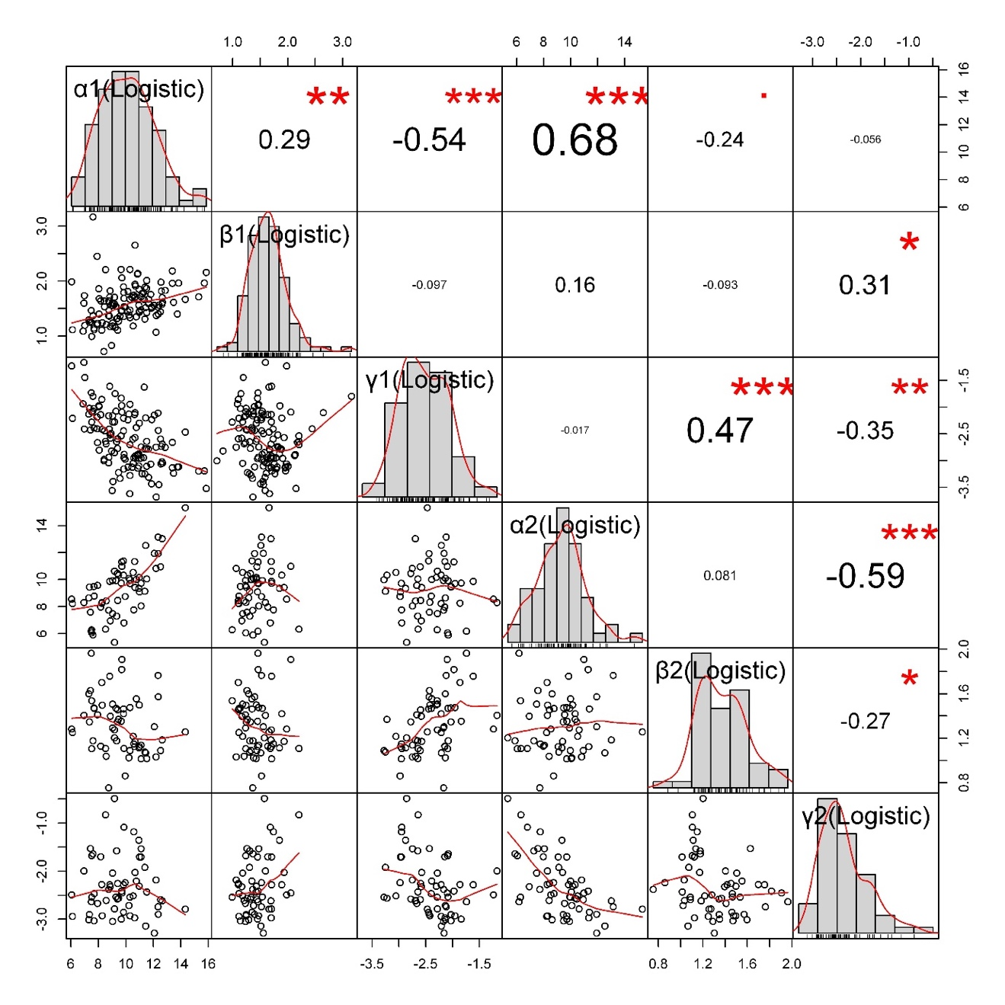

**Fig. S3. Comparison of Logistic Model (log-scaled) parameters , , and in the 1st and 2nd segments.**

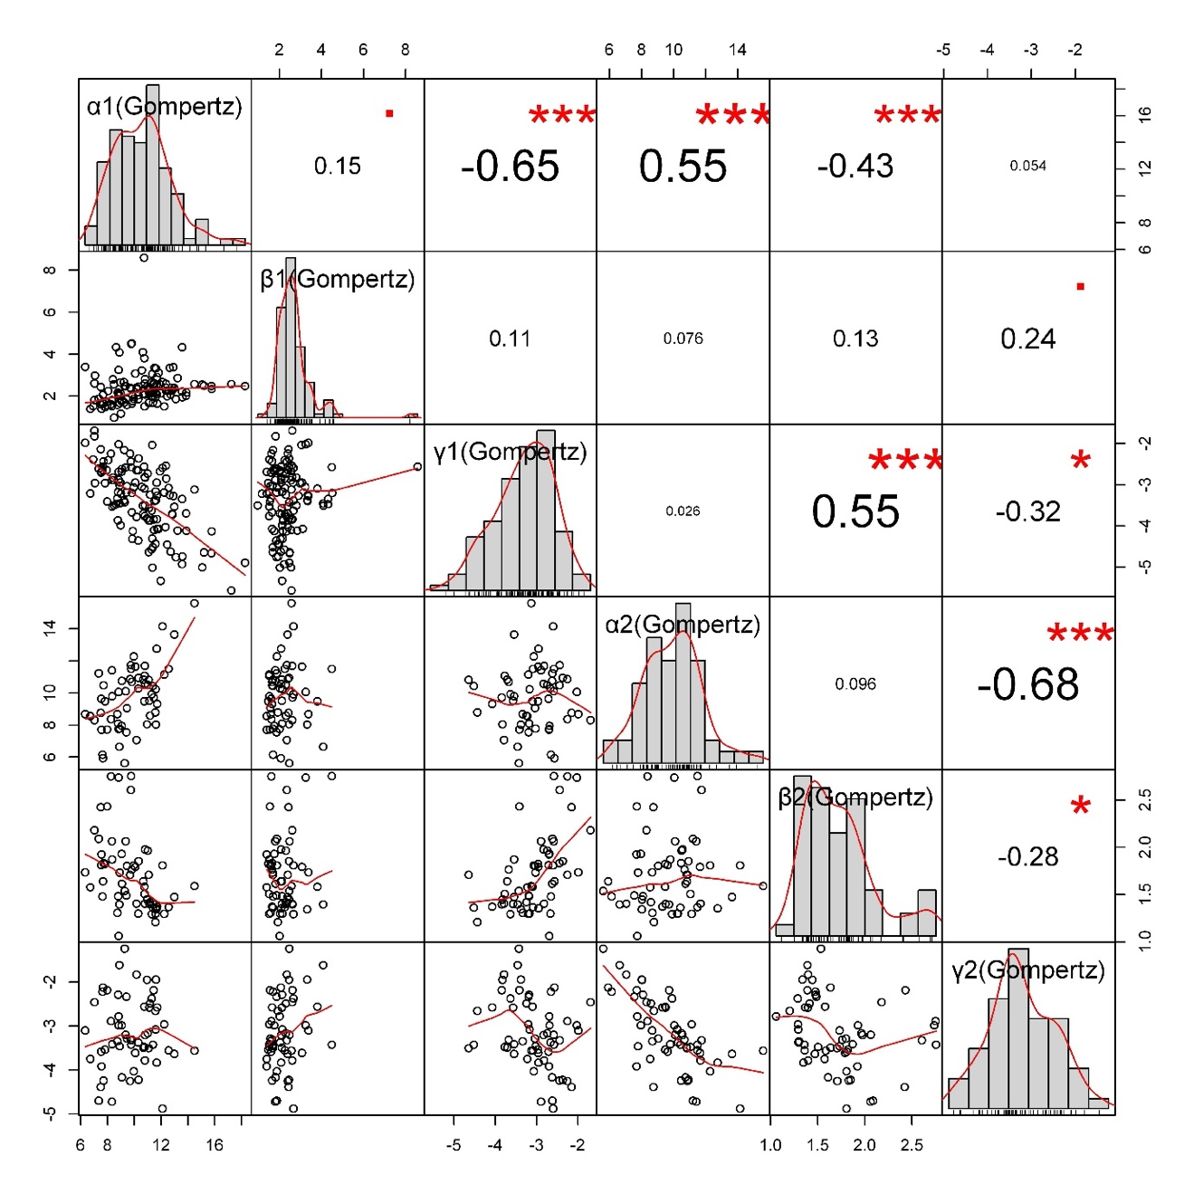

**Fig. S4. Comparison of Gompertz Model (log-scaled) parameters , , and in the 1st and 2nd segments.**

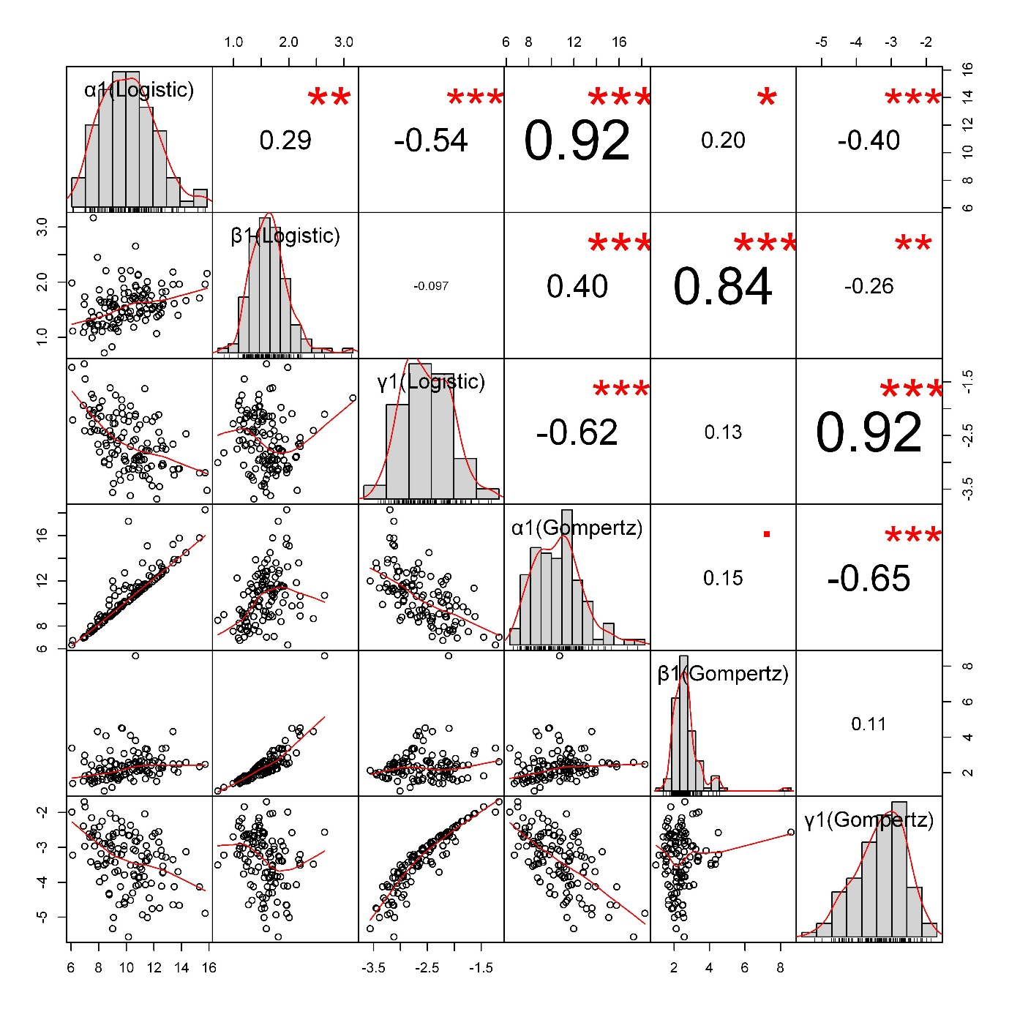

**Fig. S5. Comparison of Logistic and Gompertz Model (log-scaled) parameters , , and in the 1st segment.**

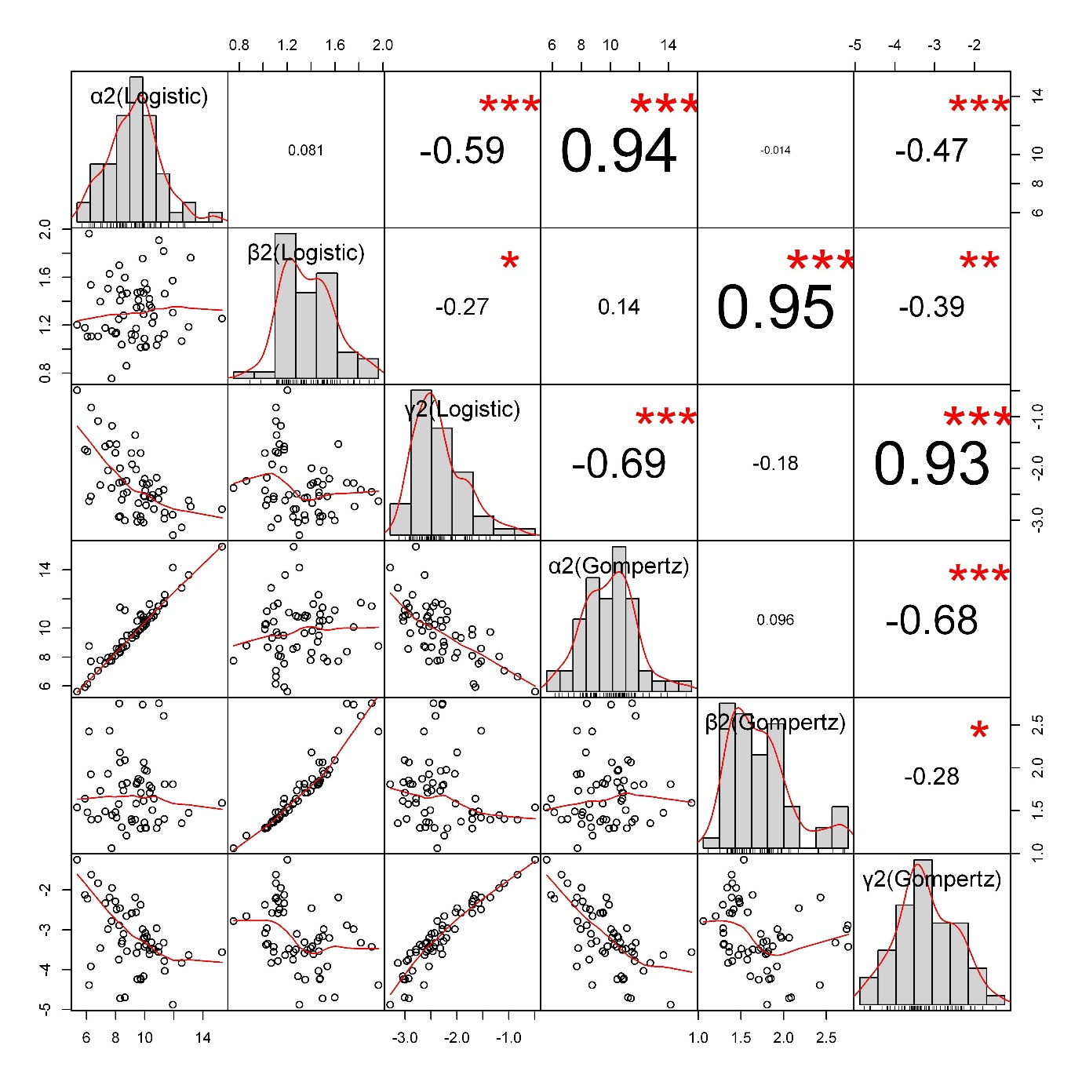

**Fig. S6. Comparison of Logistic and Gompertz Model (log-scaled) parameters , , and in the 2nd** **segment.**

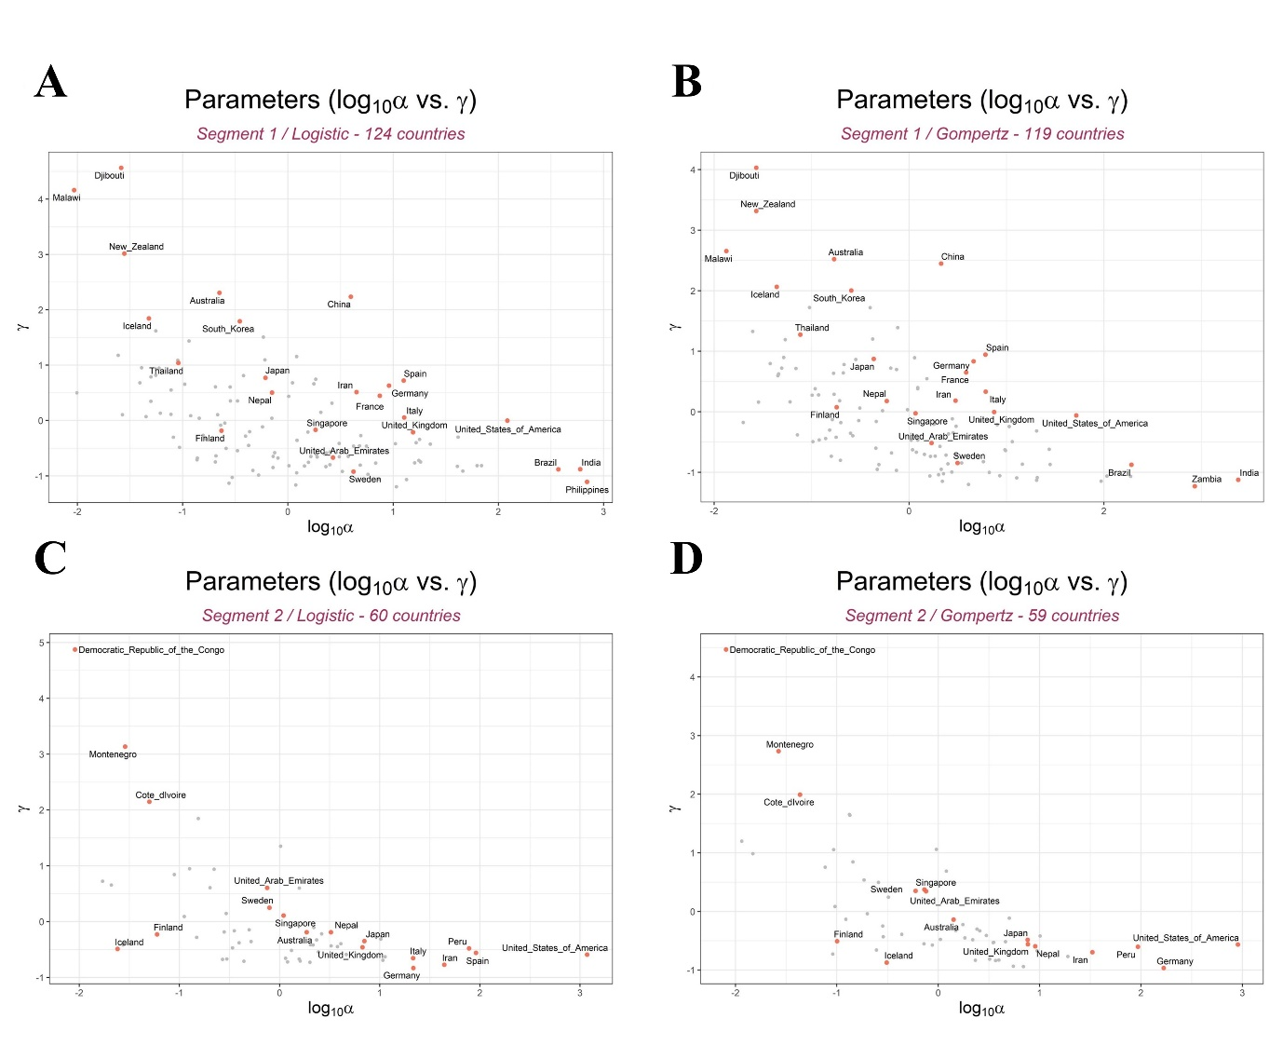

**Fig. S7. Variation of log10 maximum predicted cumulative cases () and rate of spread of COVID-19 among countries ().**